**Problem Statement:**

You work for XYZ Corporation. Their application requires a SQL service that can

store data which can be retrieved if required. Implement a suitable RDS engine

for the same.

**While migrating, you are asked to perform the following**

**tasks:**

1. Create a MariaDB Engine based RDS Database.

2. Connect to the DB using the following ways:

a. SQL Client for Windows

b. Linux based EC2 Instance

**Problem Statement:**

You work for XYZ Corporation. Their application requires a SQL service that can

store data which can be retrieved if required. Implement a suitable RDS engine

for the same.

**While migrating, you are asked to perform the following**

**tasks:**

1. Create an AuroraDB Engine based RDS Database.

2. Create 2 Read Replicas in different availability zones for better

infrastructure availability.

**Problem Statement:**

You work for XYZ Corporation. Their application requires a database service that

can store data which can be retrieved if required. Implement a suitable service

for the same.

**While migrating, you are asked to perform the following**

**tasks:**

1. Create a DynamoDB table with partition key as ID.

2. Add 5 items to the DynamoDB table.

3. Take backup and delete the table.

**Problem Statement:**

You work for XYZ Corporation. Their application requires a database service that

can store data which can be retrieved if required. Implement suitable service for

the same.

**While migrating, you are asked to perform the following**

**tasks:**

1. Create a Redshift data warehouse.

2. Using the query editor:

a. Load some data

b. Query the data

**MariaDB Assignment**

Go to AWS Management Console 🡪 RDS 🡪 Databases 🡪 Create Database

Select MariaDB

Templates 🡪 Free Tier

Master password is 12345678 and confirm master password 12345678

Keep default settings for Connectivity, Tags and Database Authentication

Go to Additional Configuration

Go to Additional Configuration

Give a name to the initial database

Firtstdb

Keep the remaining settings to defaults and click on Create database

Click on close

View credentials details

Database successfully created

It takes some time to create this database. Meanwhile download and install MySQL Workbench

MySQL Workbench installed

Now open MySQL workbench and enter the required details. Click on Store in Vault to enter the password

Click on test connection

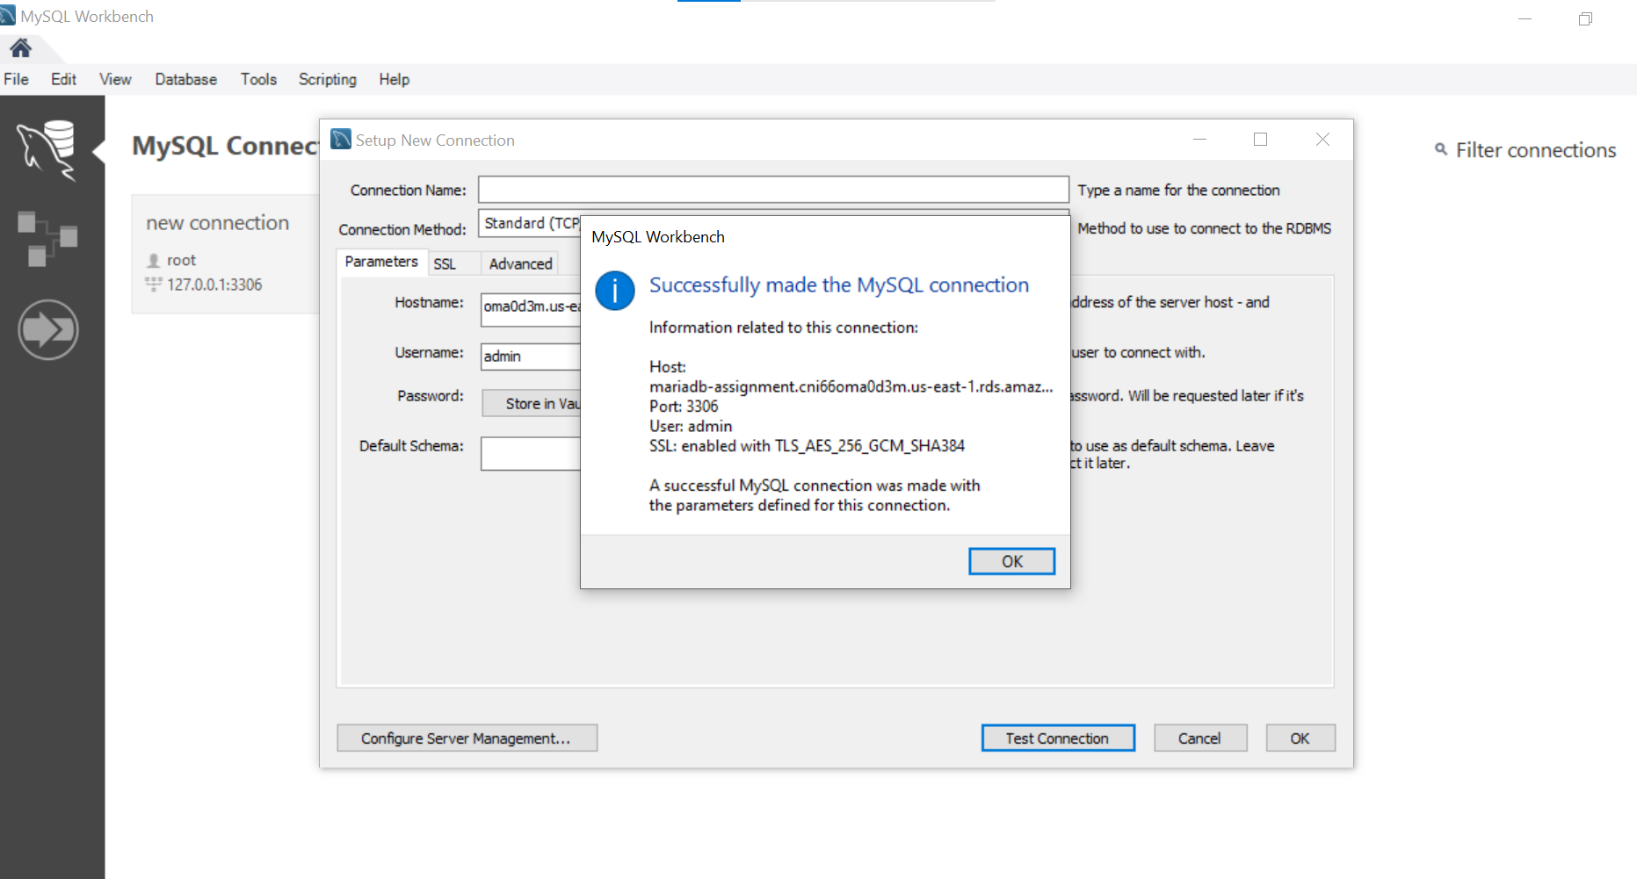

Then click on OK

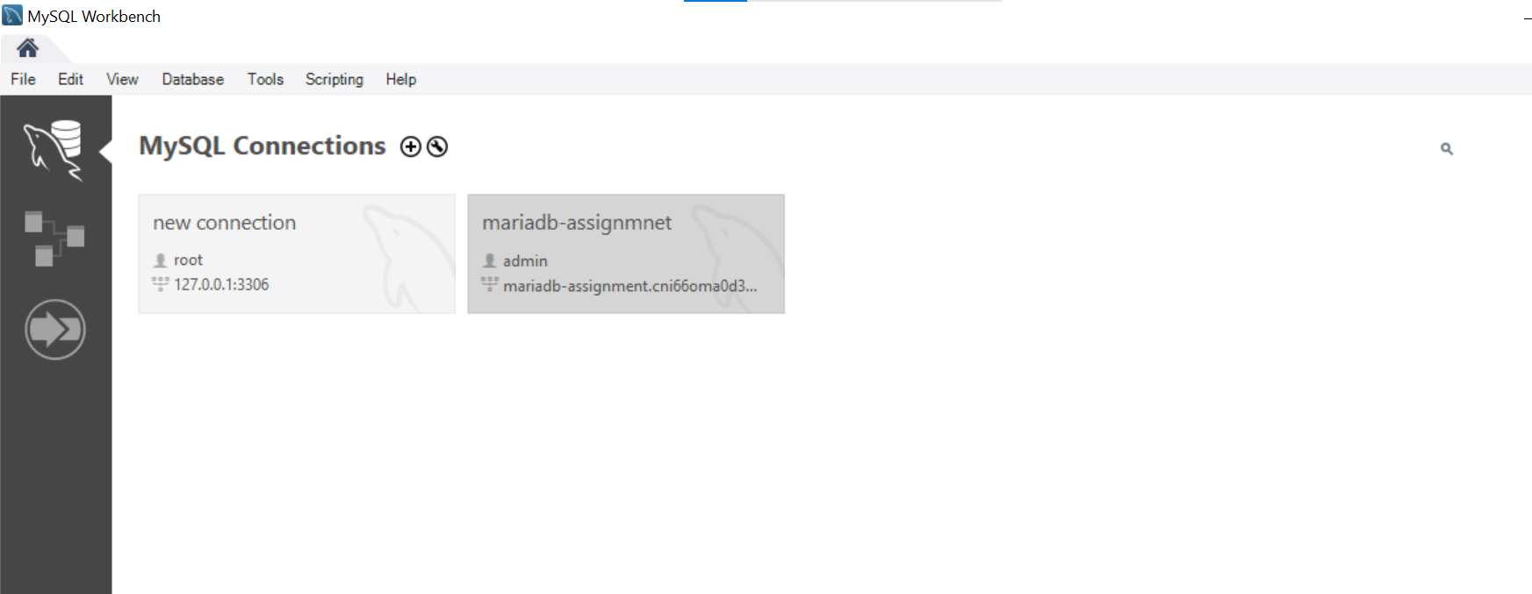

You can now run SQL queries and manage your database from the SQL client

Linux based EC2 Instance

Let’s Connect to the DB using a Linux-Based EC2 Instance. Create an Amazon Linux instance in the same VPC as the database.

Then install MariaDB client.

**sudo yum update -y >>>>> sudo yum install mariadb105 –y**

Note the **Endpoint** and **Port** from the RDS console as mentioned before.

Connect to MariaDB using the below command  
 mysql -h <endpoint> -P <port> -u <username> -p

mysql -h mariadb-assignment.cni66oma0d3m.us-east-1.rds.amazonaws.com -p 3306 -u

admin –p

**Enter password when prompted**

**12345678**

It is successfully connected. you can run SQL commands directly from the terminal

We’ve successfully set up a MariaDB RDS instance and connect to it from both a Windows SQL client and a Linux-based EC2 instance

1. Next, we’ll do AuroraDB Assignment
2. **Problem Statement:**
3. You work for XYZ Corporation. Their application requires a SQL service that can
4. store data which can be retrieved if required. Implement a suitable RDS engine
5. for the same.
6. **While migrating, you are asked to perform the following**
7. **tasks:**
8. 1. Create an AuroraDB Engine based RDS Database.
9. 2. Create 2 Read Replicas in different availability zones for better
10. infrastructure availability.

Go to AWS Management Console 🡪 RDS 🡪 Databases 🡪 Create Database

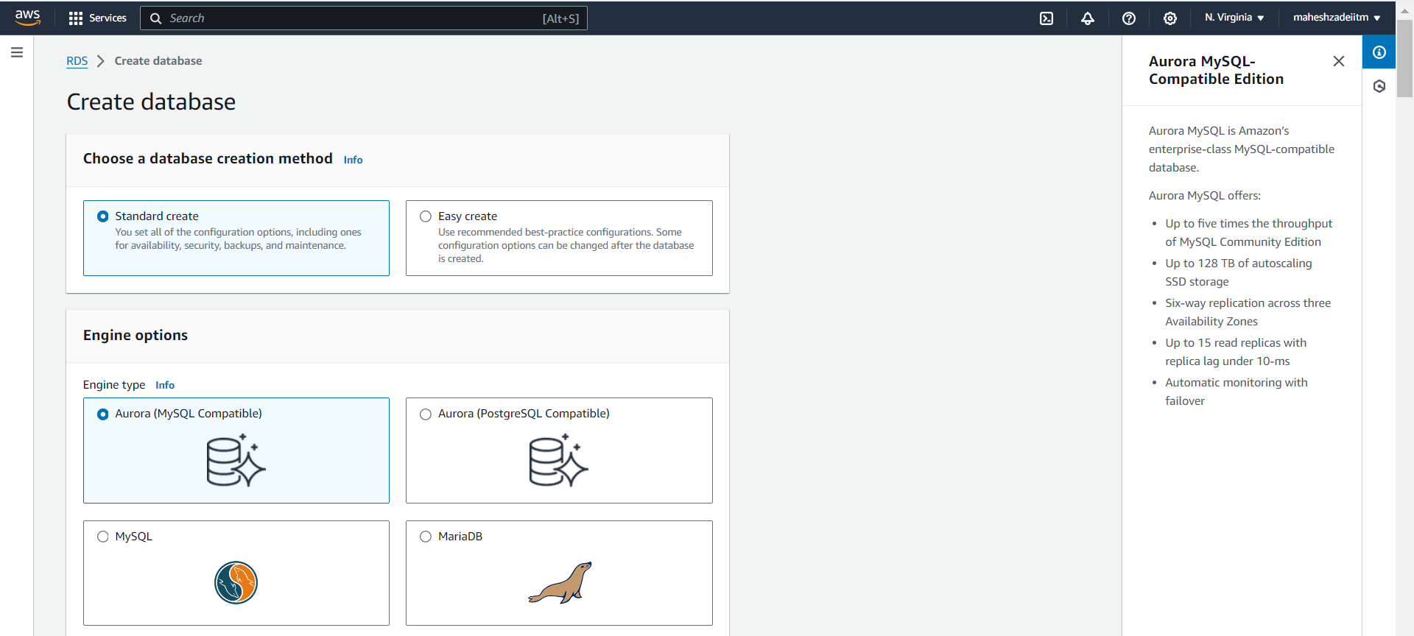

Master user admin

Password is admin#12345678

Keep default settings for Connectivity, Tags and Database Authentication

Select db t3 .medium

Go to Additional Configuration

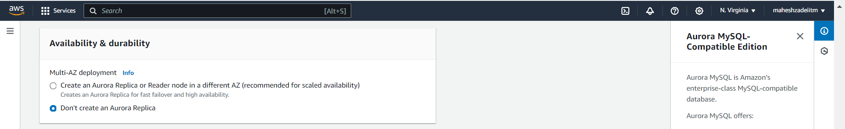

Choose default VPC

Go to Additional Configuration

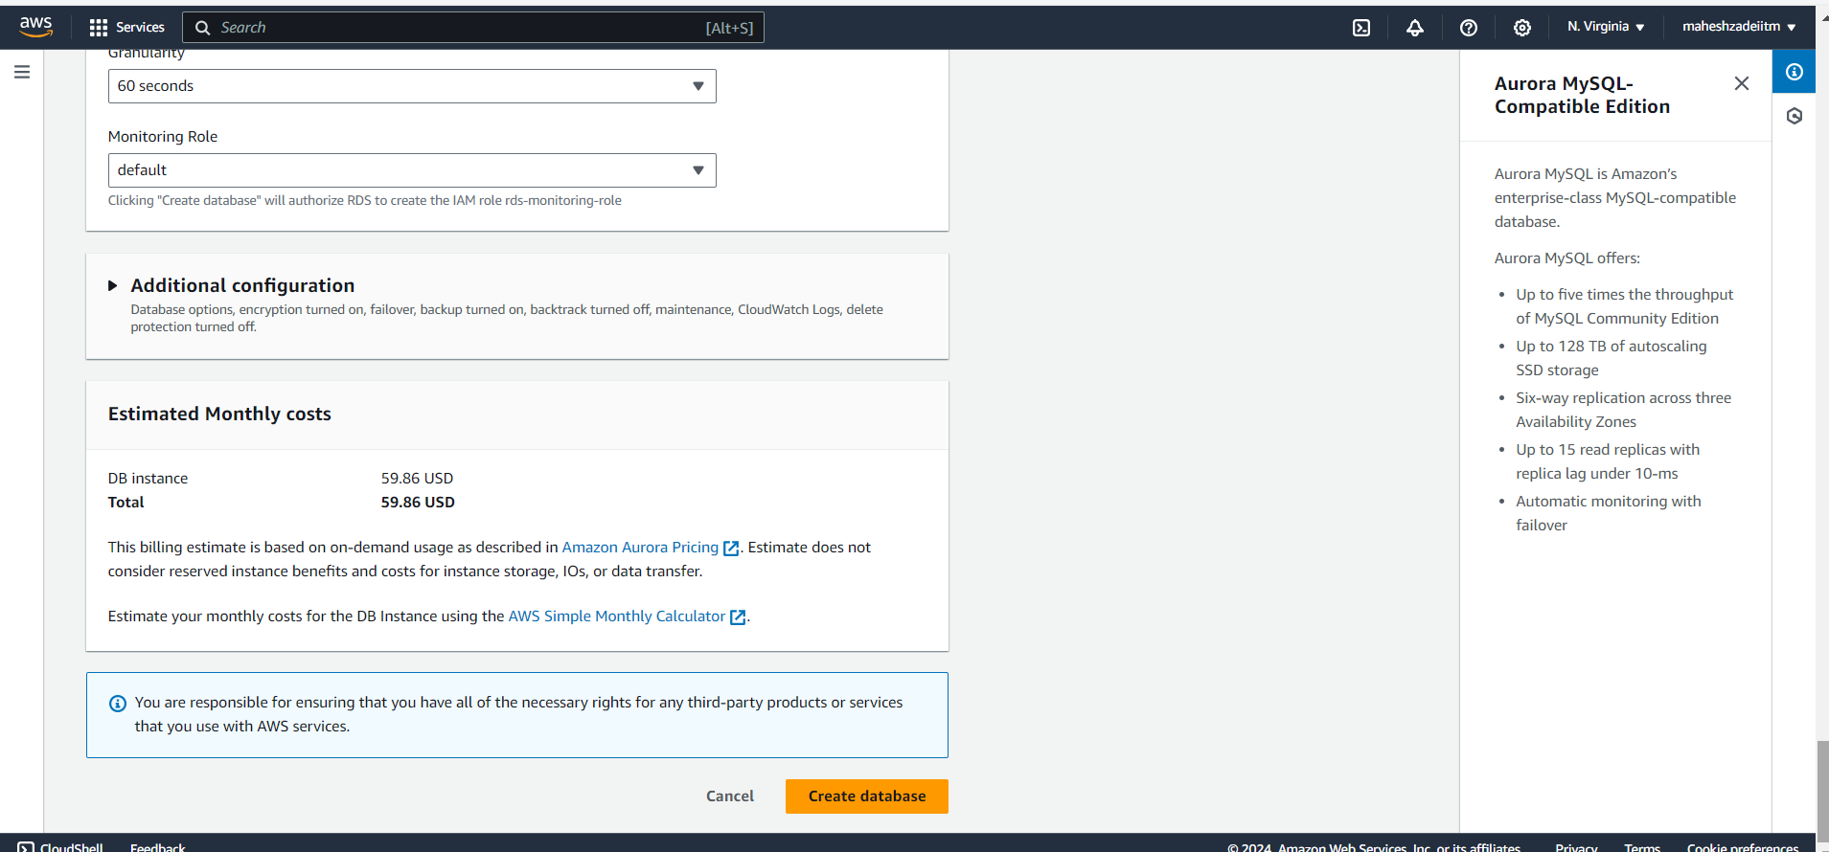

Go to additional configuration

Give a name to the initial database.

Keep the remaining settings to defaults and click on Create

Click create database

Close

database is created and is available now wait till database instance created .

note endpoint name : database-1.cluster-cni66oma0d3m.us-east-1.rds.amazonaws.com

click on view connection details

Master username : admin

Master password : admin#12345678

Endpoing : database-1.cluster-cni66oma0d3m.us-east-1.rds.amazonaws.com

Now Let’s create read replicas in 2 different Azs. Go to Actions -> Add reader

**Keep the remaining settings to defaults and click on Add Reader**

Read replica is getting created. Meanwhile, we go and create another read replica in a different AZ.

Choose cluster 🡪 Go to Actions -> Add reader

**AZ change to us-rast-1a**

